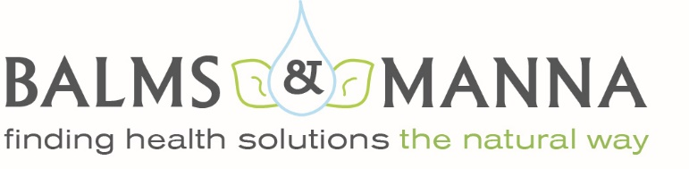
What Is SIBO?

SIBO is the acronym for “small intestinal bacterial overgrowth” or excessive bacteria in the small intestine, or small bowel. While bacteria naturally occurs throughout the digestive tract, in a healthy system, the small intestine has relatively low levels of bacteria; it’s supposed to be at highest concentrations in the colon.

The small intestine is the longest section of the digestive tract. This is where the food intermingles with digestive juices, and the nutrients are absorbed into the bloodstream. If SIBO is indicated, malabsorption of nutrients, particularly fat-soluble vitamins and iron, can quickly become a problem. This can produce symptoms commonly associated with IBS including gas, bloating and pain and may even lead to damage of the stomach lining.
This is a condition that takes patience, perseverance and a change in diet. It includes a healing diet, and some foods should be avoided until the gut flora is back in balance.
High FODMAPs Food (to avoid)

VEGETABLES-
- Artichokes
- Asparagus
- Cauliflower
- Garlic
- Peas
- Leeks
- Mushrooms
- Onions
- Sugar snap peas

FRUITS-
- Apples
- Cherries
- Dried fruit
- Mango
- Nectarines
- Peaches
- Pears
- Plums
- Watermelon
- Fruit juices

DAIRY-
- Cow’s milk
- Custard
- Evaporated milk
- Ice cream
- Soy milk
- Sweetened condensed milk
- Yogurt

PROTEINS-
- Legumes
- Processed meats

BREADS-
- Wheat
- Rye
- Barley

SWEETENERS-
- High fructose corn syrup
- Honey
- Sweeteners-sorbitol, lactitol, maltitol, xylitol and erythritol

NUTS-
- Cashews
- Pistachios

Low FODMAPs Food (to enjoy)

VEGETABLES-
- Alfalfa/bean sprouts
- Bamboo shoots
- Bok choy
- Carrot
- Chives
- Cucumbers
- Fresh herbs
- Leafy greens
- Tomato
- Eggplant
- Green beans
- Zucchini
- Sweet potatoes

FRUITS-
- Bananas
- Berries
- Melons
- Grapes
- Kiwi
- Lemon
- Lime
- Mandarin
- Orange
- Passion fruit
- Pineapple
- Rhubarb
- Tangerine

MILK-
- Almond, coconut or rice milk
- Raw hard cheese

PROTEINS-
- Eggs
- Grass fed beef/lamb
- Free range chicken/turkey
- Wild caught fish
- GF bread, oats, pasta
- Non-GMO rice, corn
- Quinoa
- Sourdough spelt

SEASONINGS-
- Avocado, coconut, grapeseed oils
- Grass fed butter
- Maple syrup
- Mayonnaise
- Mustard
- Olives
- Vinegar
- Dark chocolate

NUTS-
- Macadamia
- Organic peanuts
- Pecans
- Pine nuts
- Walnuts
- Pumpkin seeds

